The University of Azad Jammu and Kashmir, Muzaffarabad

Name: Alishba Zakir
Roll No: 2024-SE-02
Course: DataBase Systems
Course Code: CS-2204
Lab: 02
Submitted To: Engr. Awais Rathore
Submitted By: Alishba Zakir
Date: Mar, 2026

Department Of Software Engineering
Design and Implementation of a Point of Sale (POS) Database
Objective:
The objective of this lab was to create an E-Commerce Database Management System using phpMyAdmin in XAMPP. The project included creating tables, relationships, constraints, triggers, and exporting the database.
Software Used:
- XAMPP
- phpMyAdmin
- MySQL
Tables Created:

The following tables were created:
- roles
- users
- categories
- products
- orders
- order_items

Relationships:
The following relationships were implemented:
roles → users
categories → products
users → orders
orders → order_items
products → order_items
Constraints and Triggers:
The following validations were applied:
Email cannot be empty
Password cannot be empty
Password must contain at least 6 characters
Product stock should not be too low
Triggers were created for automatic validation before inserting data.
ER Diagram:
The database included relationships between users, products, categories, orders, and order items.
Tables:
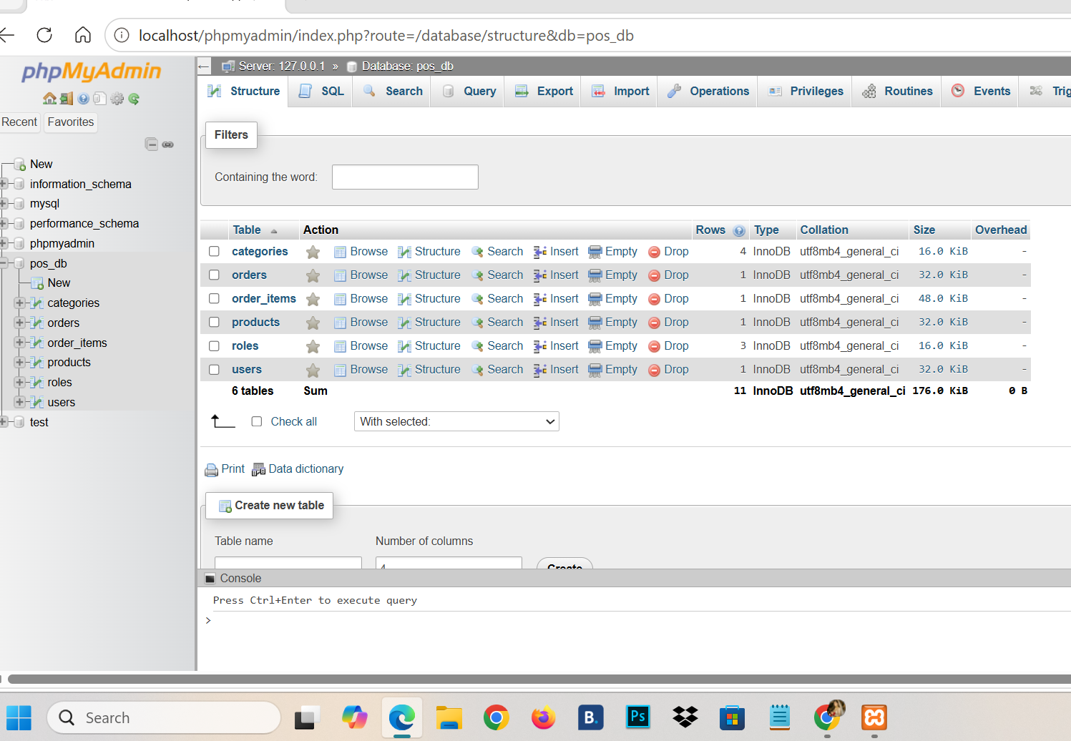

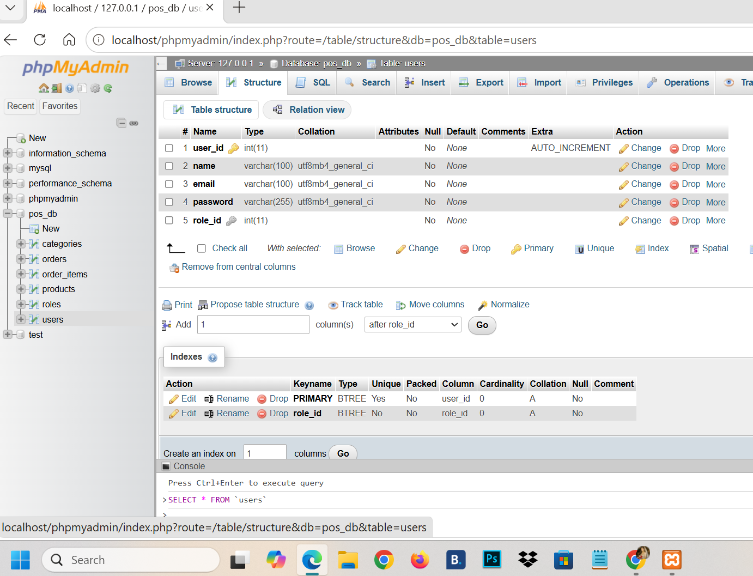
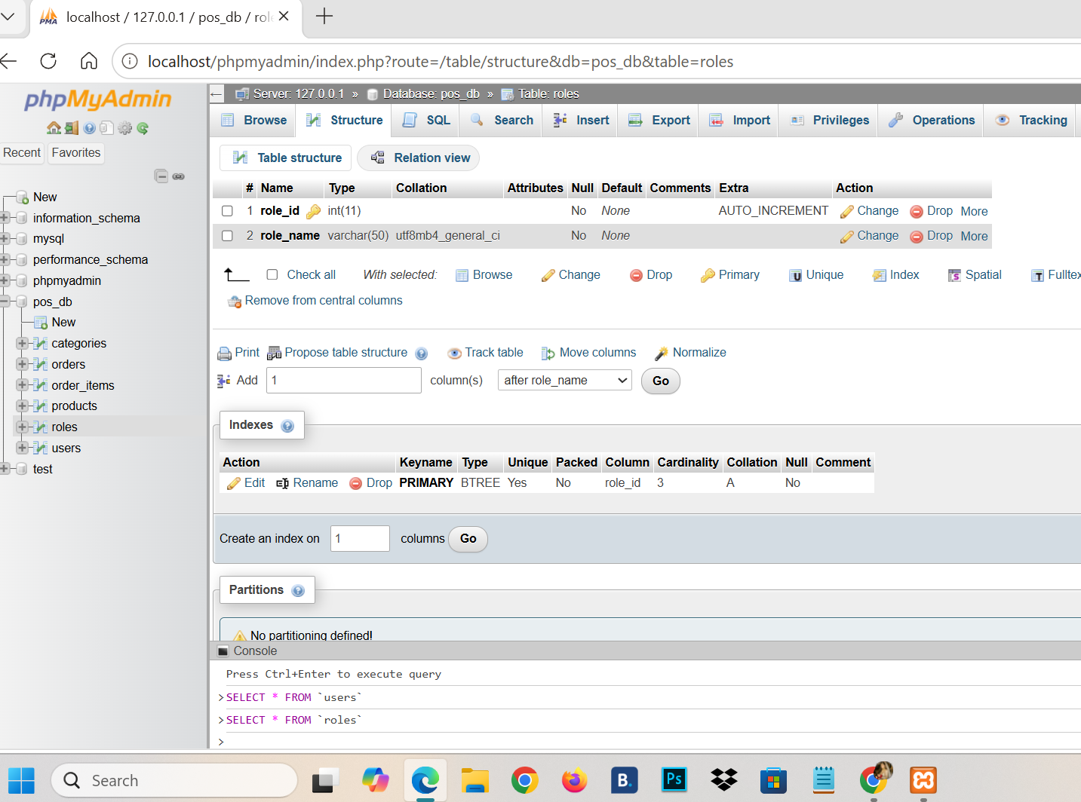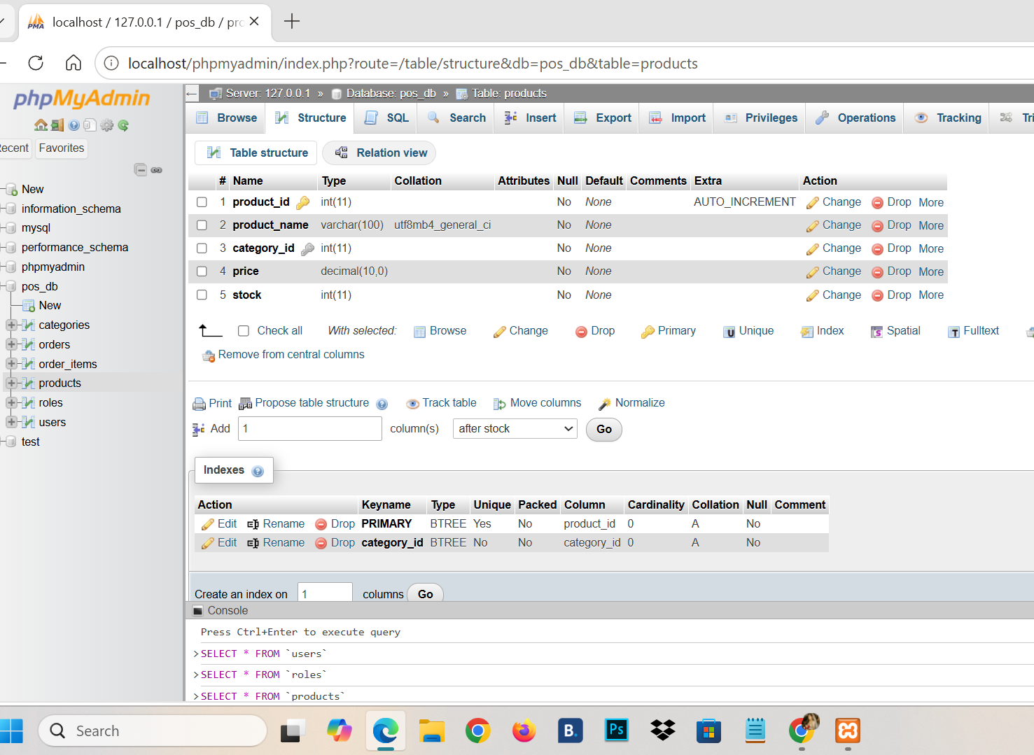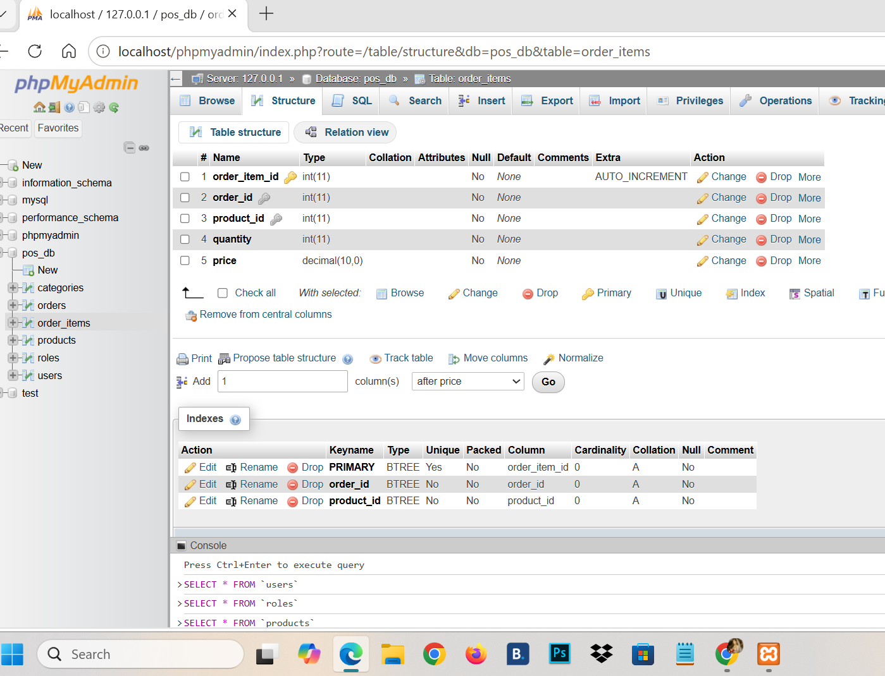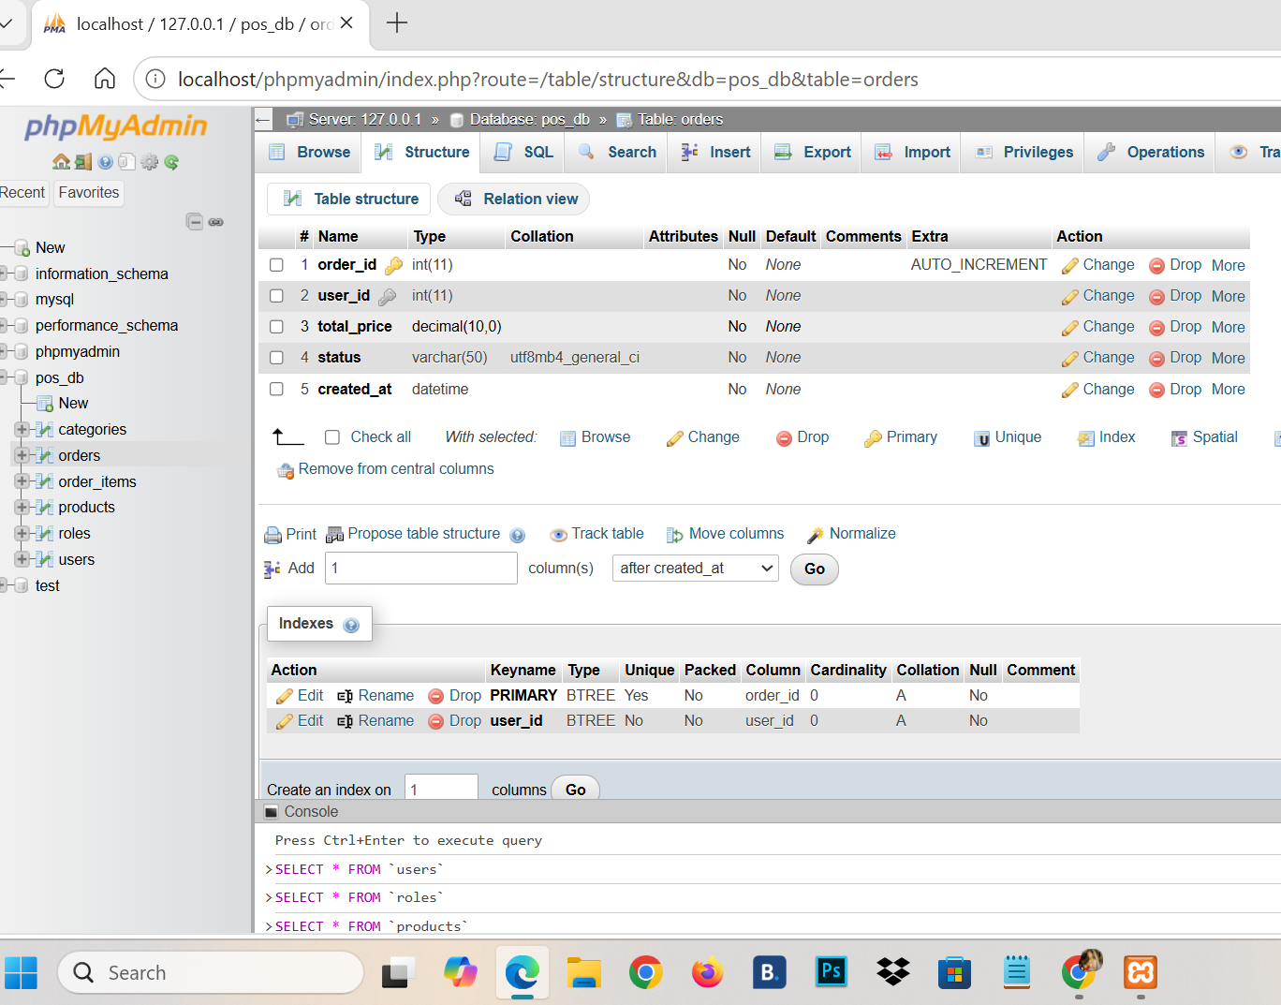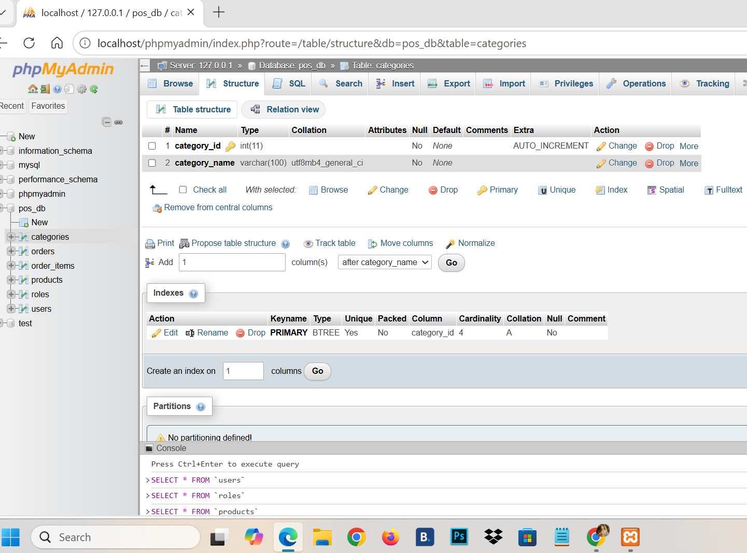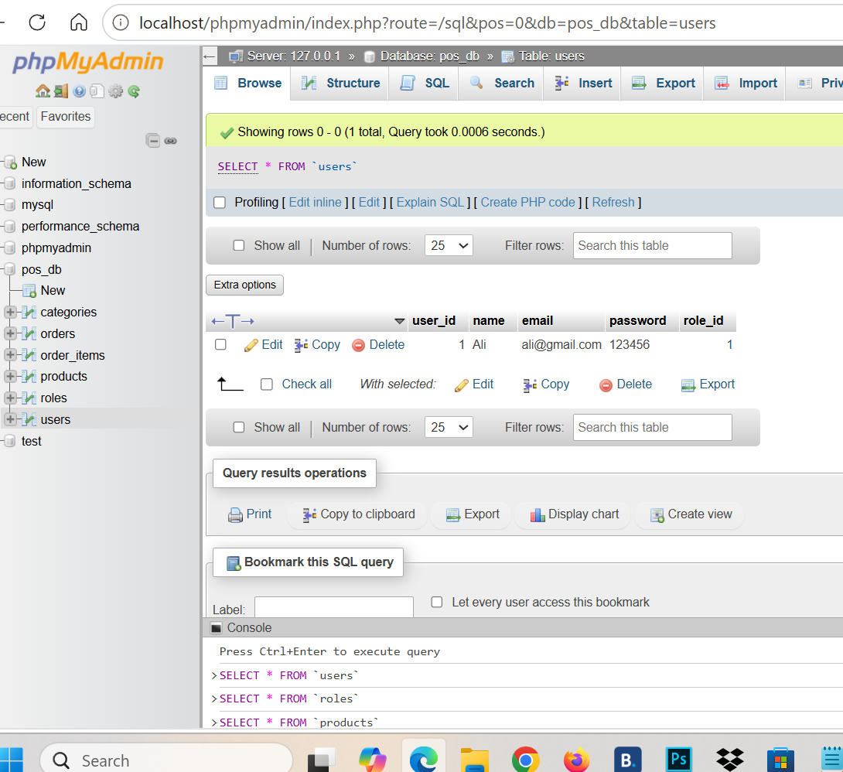

Roles:
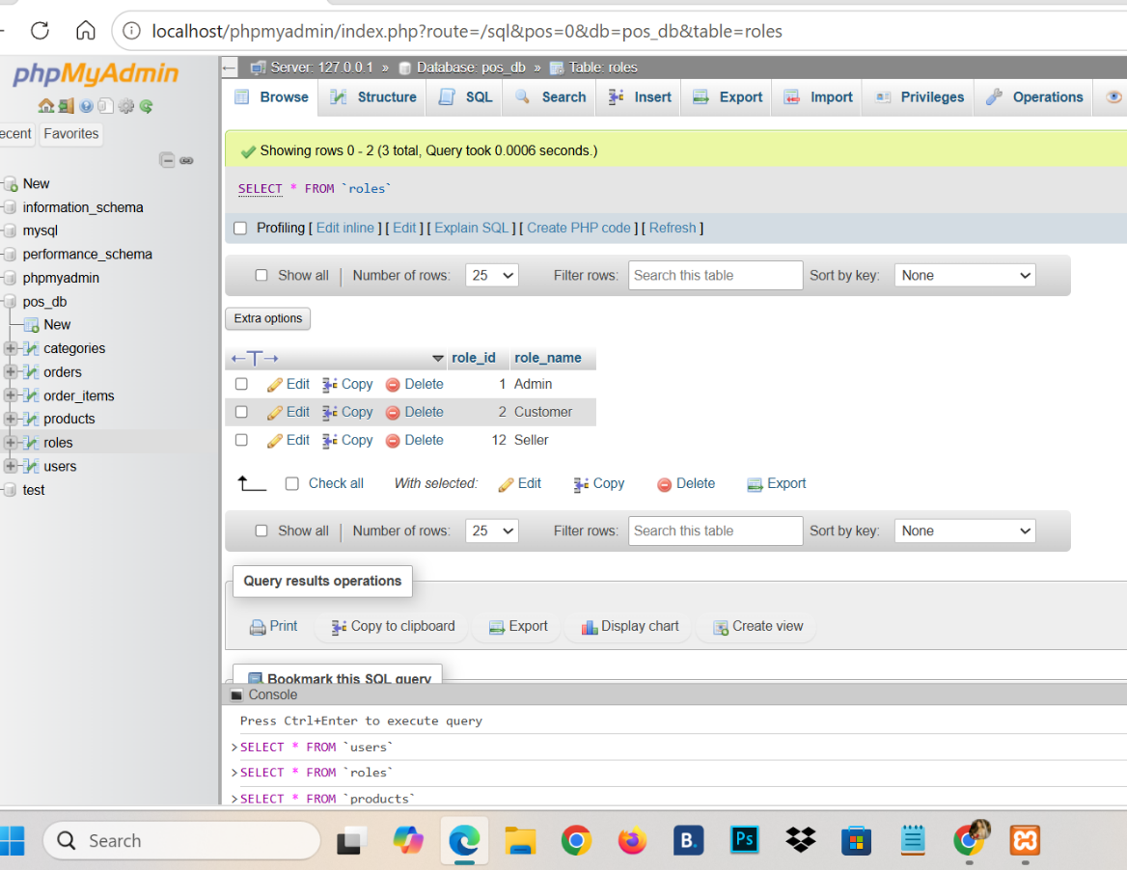

Inserting Data:
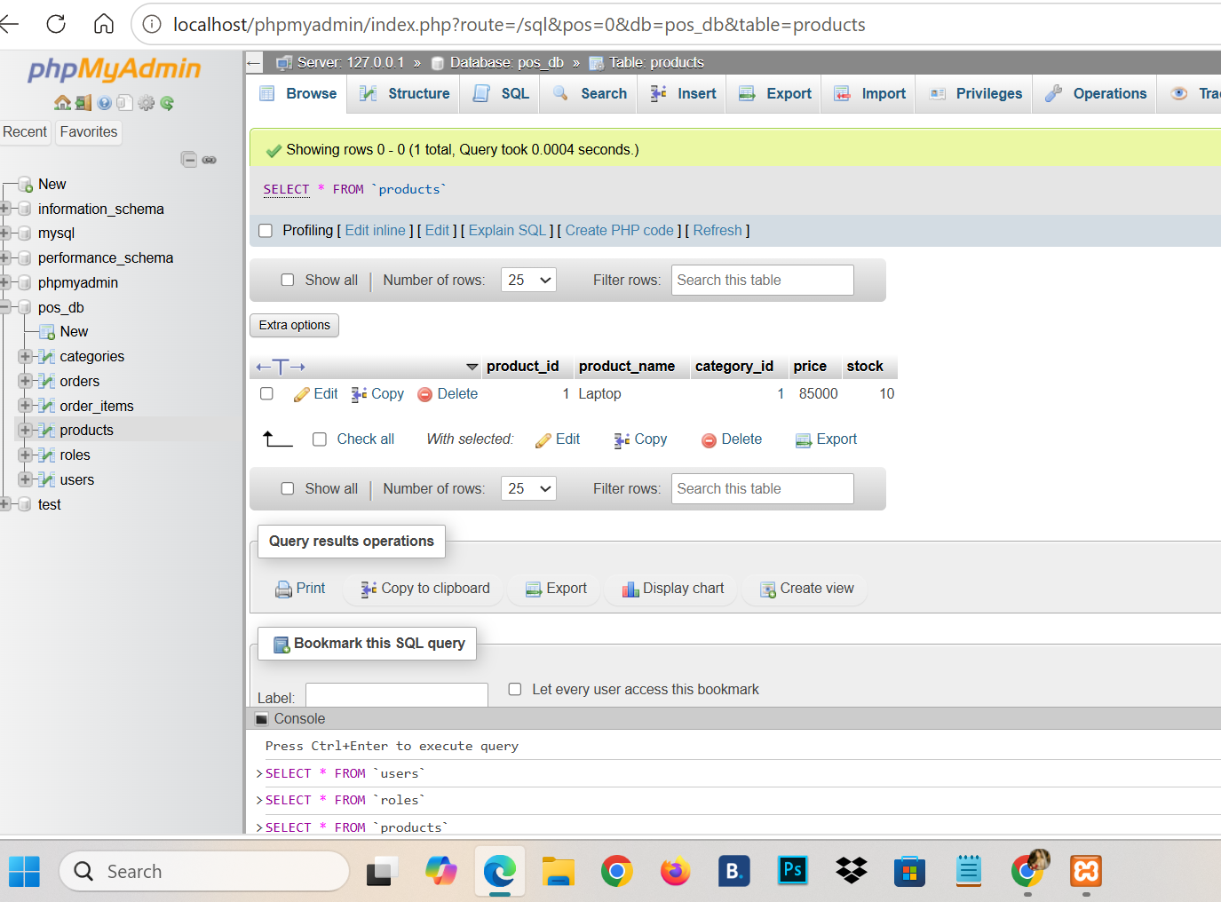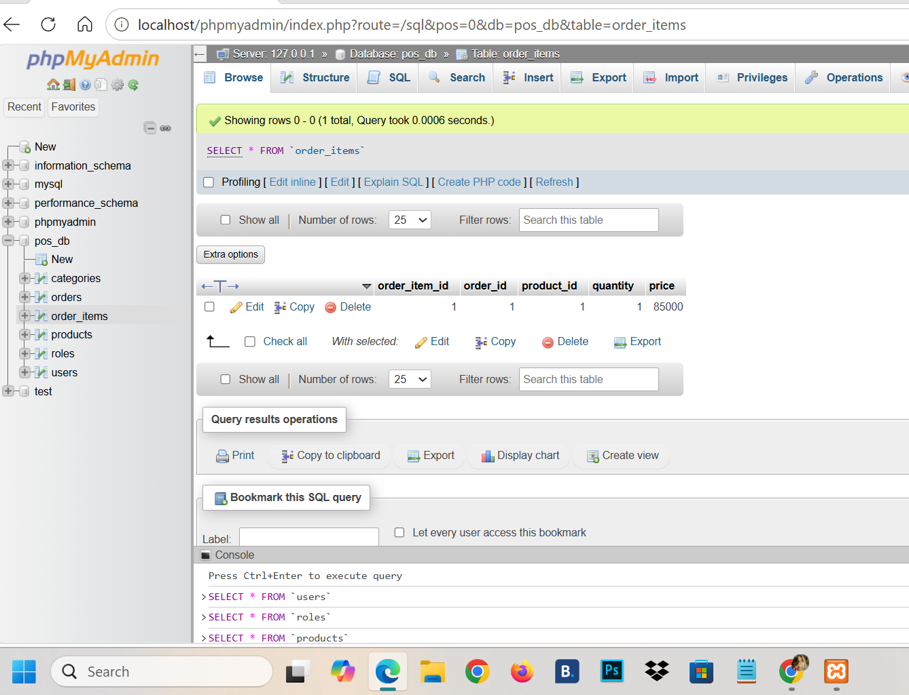
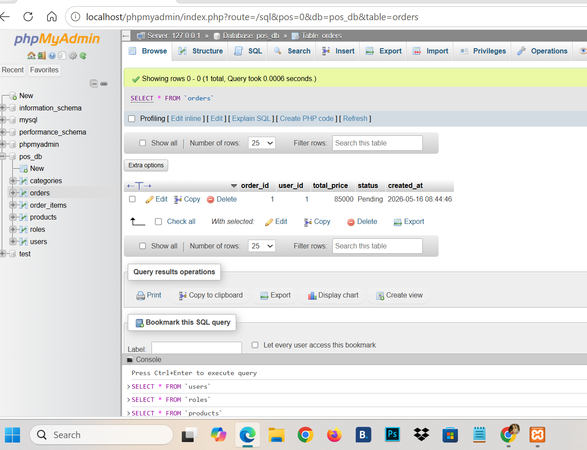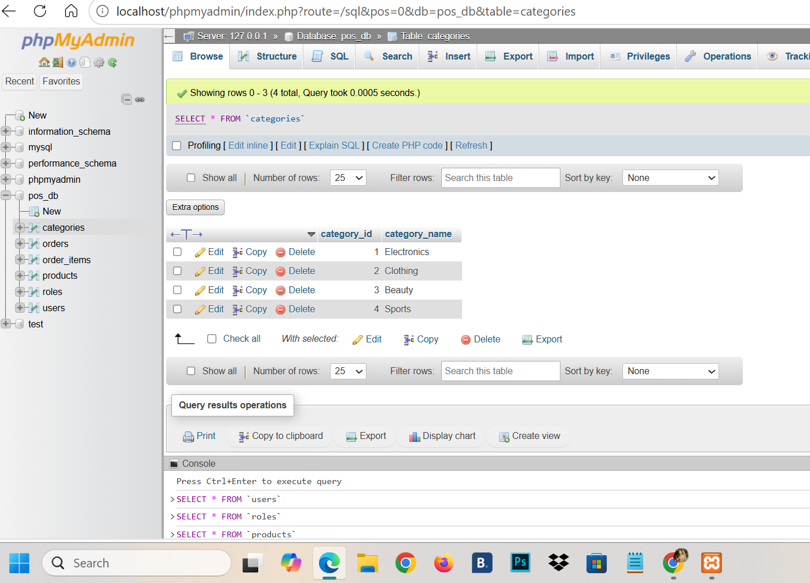
RelationShip:
roles → users

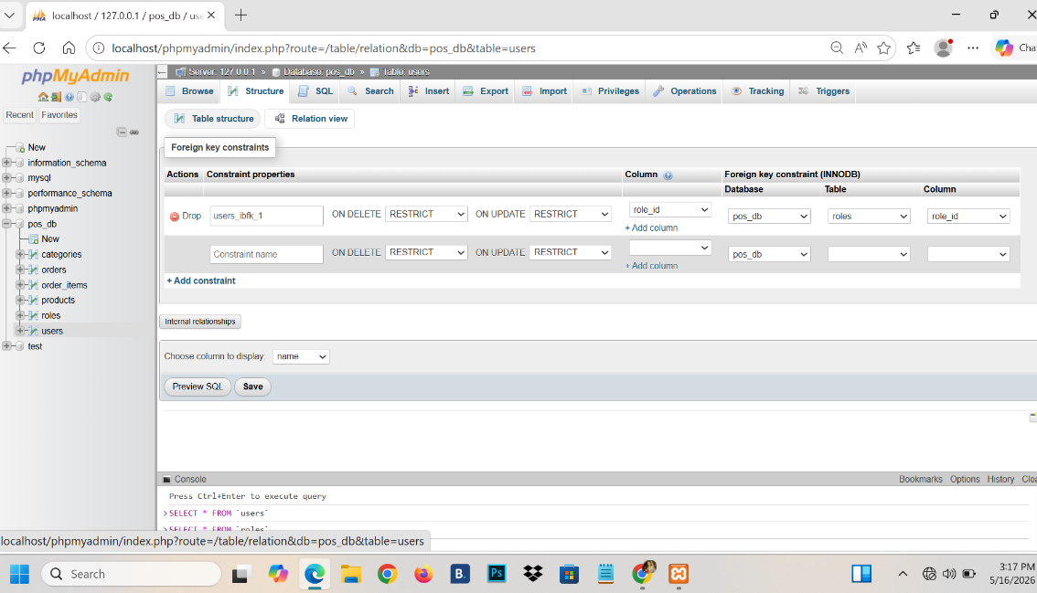
categories → products
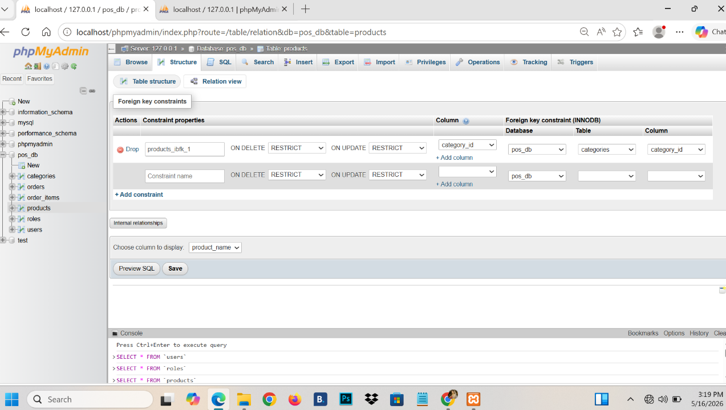

orders → order_items

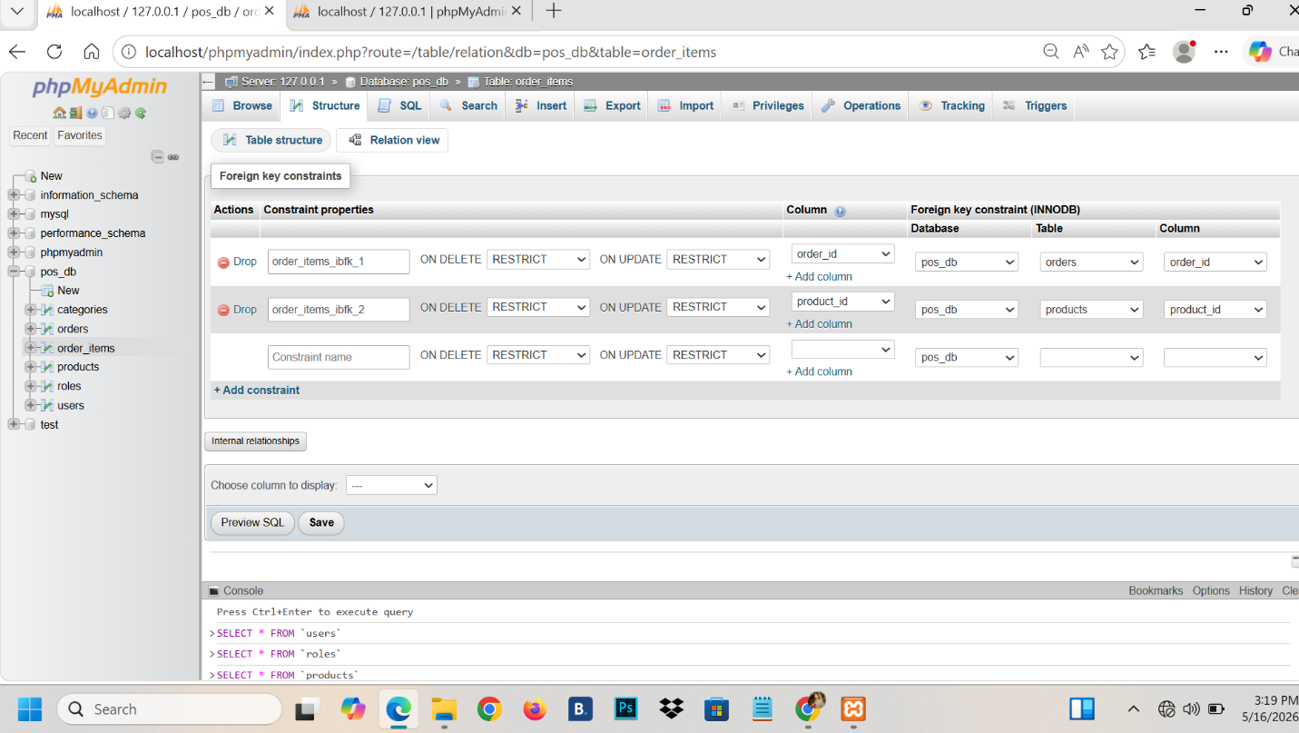
users → orders

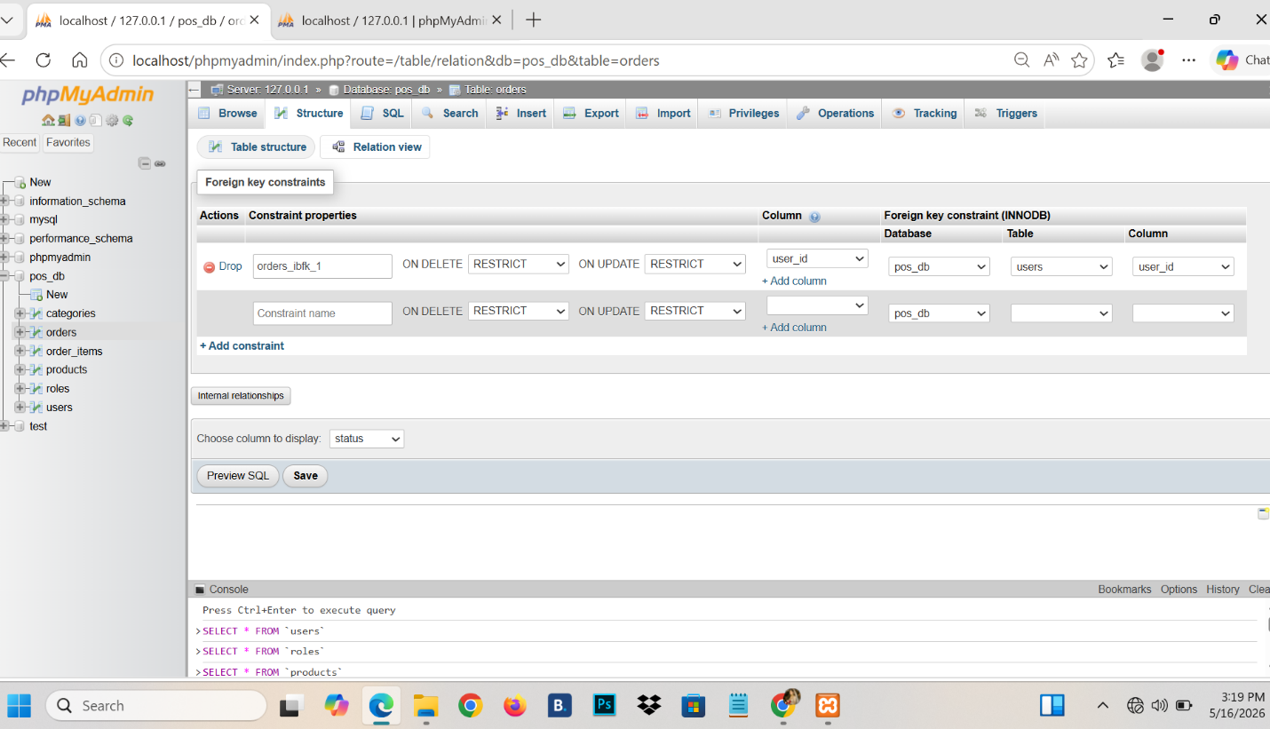
products → order_items
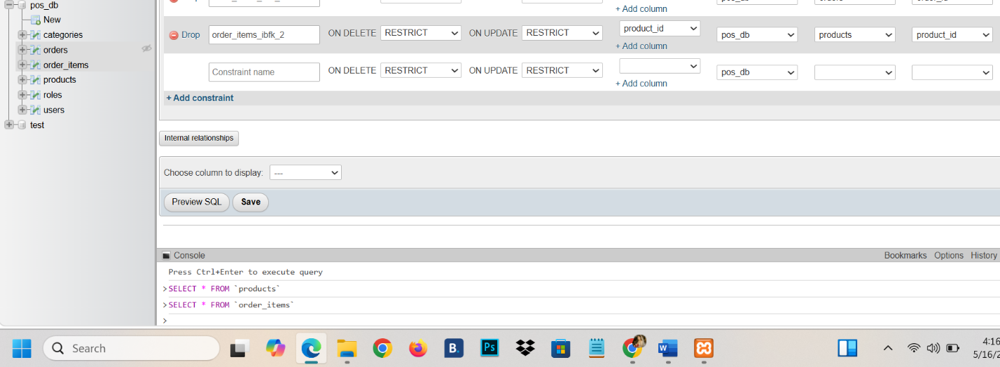
Triggers
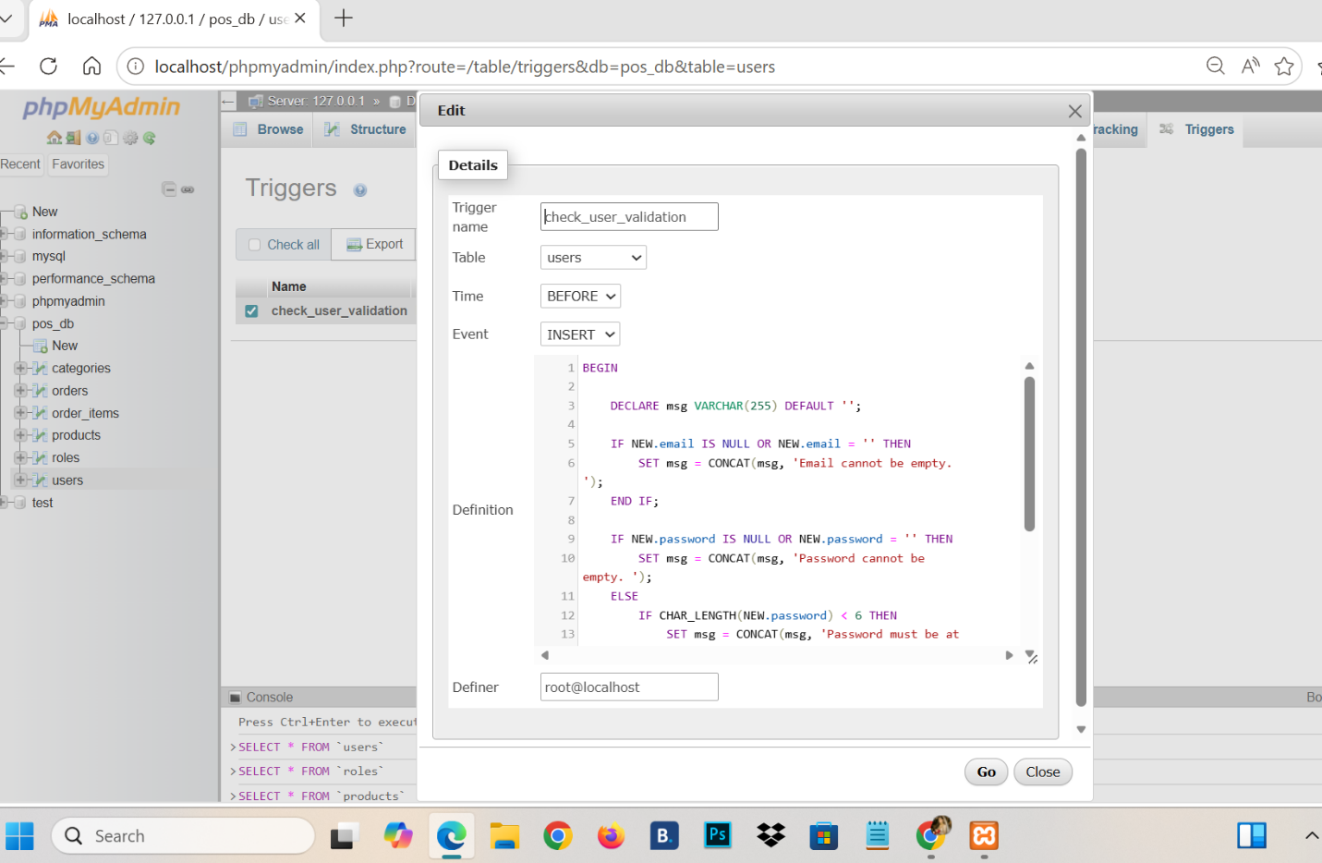

ER _Diagram:

